Vertebrate Morphology
Web Project – Squaleomorph Sharks
Kevin Redding

A Short Summary of Squaleomorphs
Squaleomorph Sharks

Squalea, the class of squaleomorph sharks is comprised of a vast amount of sharks ranging from the Squalus sharks that were dissected in lab to the strange sawfish and the flattened stingrays. These sharks are not of the same class of animal as the Hollywood depiction of sharks. Great White Sharks and other “typical” sharks belong to the class Galea. The order of Squalea is made up of many orders of sharks, each containing one to many species of shark, skate, or ray. Many of these sharks live in deep-sea habitats and have unusually long gestation periods.
The living sharks of today are classified into three different classes, depending on which expert is referred. The sharks one typically imagines, the Galeomorphs, the Squaleomorphs, and the ancient chimaeras. Chimaeras are further removed from both of these groups and do not share a number of the ancestors shared by the other two living groups.

Chlamydoselachiformes
These sharks comprise the Frilled Sharks; a very strange deep-sea shark is eel-like in appearance. The name is derived from the frilly gill slits belonging to this species. The Japanese call this shark the silk shark. The diversity of this group seems to be very low with only one known species and most of the specimens that have been observed are from Japanese waters. Its teeth are shaped like miniature tridents or pitchforks, and are used to capture its prey of deep-sea squids and teleosts. Some paleontologists think that this may be a survivor of the cladodont sharks, but musculature in the shark makes this probably false.
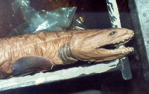

Hexanchiformes
The order of cow sharks is comprised of about 4 species found in cold waters of the Atlantic, Pacific, and Indian oceans. They have an extra pair or two of gill slits. These sharks are more closely related to frilled sharks than other Squaleoformes. The teeth of these sharks differ, however the bottom teeth are strangely shaped like a comb. Some of these sharks can grow to be around 25 feet long.

Echinorhiniformes
Bramble sharks are a low diversity class of sharks containing two species. The species’ name (echino- hedgehog) comes from the enlarged denticles covering its skin. They feed on fishes, crabs, octopus, and squid and can grow to lengths of 12 feet or more.

Squaliformes
One of the larger, more diverse groups within the Squalea class is the dogfish shark. An example of this order is the Squalus acanthias, or spiny dogfish. Many species within this order are bioluminescent and can be found in almost any waters in the world, including the polar regions of ocean. The diversity within this group is outstanding with size ranging from the smallest living shark, the Dwarf Lanternshark, to the very large Greenland shark. The spiny dogfish is the most studied of all sharks and was a pest to fisherman. According to early 20th century Massachusetts’s officials, hundreds of thousands of dollars were lost each year in the fishing industry due to dogfish attacking nets.

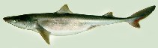

One of the strangest sharks in the water is the cookie-cutter shark. The brightly bioluminescent shark attacks large ocean creatures and uses its teeth as a cookie-cutter to remove flesh from their bodies.
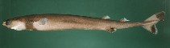
Another strange example of this group is the roughsharks. These sharks have large sail-like fins and papillae covering the mouth. They are found in deep ocean.

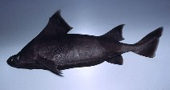

Squatiniformes
Angel sharks are dorsoventrally flattened sharks that live on the bottom of the ocean waiting to ambush their prey. Most grow to a length of about five feet. These sharks resemble the rays and skates of the Batoid class, but are not closely related. There are about 18 species of angel sharks.

Pristiophoriformes
The diversity of squaleomorphs is especially apparent in the rest of the sharks to be discussed, beginning with the sawsharks. These sharks, like the sawfish, have a long flattened snout with teeth around the edge, thus giving it a saw-like appearance. However, they are more slender than their batoid counter parts. These sharks occasionally come into small bodies of brackish to freshwater, but usually stay marine. They have long barbels that hang from the nasal region. The saw-like snout is used along with other electroreceptors to help find buried prey. There are eight species of sawsharks.
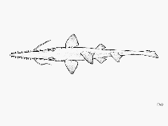

Pristiformes
The batoids (sawfish, sharkfin guitarfish, shovelnose guitarfish, electric rays, skates, and stingrays) make up about 56% of elasmobranch diversity. Sawfish are a lot like sawsharks, only with thicker bodies and no nasal barbels. The sawfish differs from the sawshark in the eyelid too. The sawshark has a moveable eyelid like sharks and the sawfish does not have this. Many are endangered because of heavily fished areas and pollution. The snout is used to kill fish and dig up crustaceans and other small buried creatures.
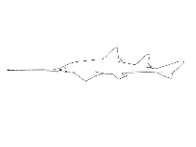

Rhiniformes
The sharkfin guitarfish shows the developing shape of rays and skates with the angel shark style of eye and mouth placement. There is only one species in this order that inhabits the Indian and West Pacific oceans. The species grows to a length of about ten feet and feeds on bottom-dwelling creatures with a strangely shaped mouth.

Rhynchobatiformes
Another type of guitarfish, the shovelnose guitarfish, is a more diverse group containing about 44 species. Again, the batiform type of flattened body is present, but the nose is more pointed than that of the sharkfin guitarfish. Some species are fished for the sharkfin soup that some cultures find as a delicacy.

Torpediniformes
The electric rays are some of the fish in the sea that are able to produce sizeable amounts of voltage with the use of special types of muscular organs. These are used to subside prey and also to give out warning shots to potential predators. There are 69 species of electric rays found in the tropical oceans.
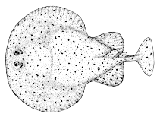

Rajiformes
Skates look like pointy nosed rays. They live along the bottom, once again following the ray type of lifestyle, thus having the flattened body with the mouth on bottom and the eyes on top. The teeth in these later forms of batoids are flattened, which makes it easier to eat the crustaceans that live on the bottom of the ocean that they occupy. Skate eggs are protected in a tough keratinized case, which are eaten by other marine animals.

Myliobatiformes
Stingrays are another very diverse group within Squalea. They encompass some 178 species. Many of them have spines on the tail that are poisonous. There are about 1,500 stingray related accidents each year in the United States. Most live on the bottom of the seabed, but some are free swimming such as the enormous manta ray, which can have a wingspan of up to 22 feet. Most live in marine environments, however there is a species of river stingrays, which have lost the ability to live in the ocean and live in brackish to freshwater exclusively.
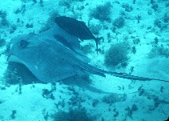

Squaleomorphs
Order | Common Name
Chlamydoselachiformes | Frilled Sharks
Hexanchiformes | Cow Sharks
Echinorhiniformes | Bramble Sharks
Squaliformes | Dogfish Sharks
Squatiniformes | Angel Sharks
Pristiophoriformes | Sawsharks

Batoids
Pristiformes | Sawfishes
Rhiniformes | Sharkfin Guitarfish
Rhynchobatiformes | Shovelnose Guitarfish
Torpediniformes | Electric Rays
Rajiformes | Skates
Myliobatiformes | Stingrays

Squaliformes
Family | Common Name
Squalidae | Dogfish
Centrophoridae | Gulpers
Etmopteridae | Lanternsharks
Oxynotidae | Angular Roughsharks
Somniosidae | Sleeping Sharks
Dalatiidae | Kitefin Sharks

See appendix for chart
See appendix for chart.

